**IST 263 Project Milestone 1**

**Name**: Julian Frucht

**Description**: Submit a description below of the idea for your website project. This proposal should be 50-100 words.

My website will be called “The Official Guide to Knicks History” and highlight iconic players and moments throughout the history of the New York Knicks. The website will feature great players spanning from Richie Guerin in the 1950s and ‘60s to Jalen Brunson in the 2020s, as well as memorable moments such as when Ossie Schectman scored the first basket in NBA history for the Knicks in 1946, the teams two championships in the 1970s, and their first Eastern Conference Finals appearance in a quarter century in 2025.

**3 Pages:** Include some information about what will be on each of the three pages in your website.

1. What will be on the home page?  
   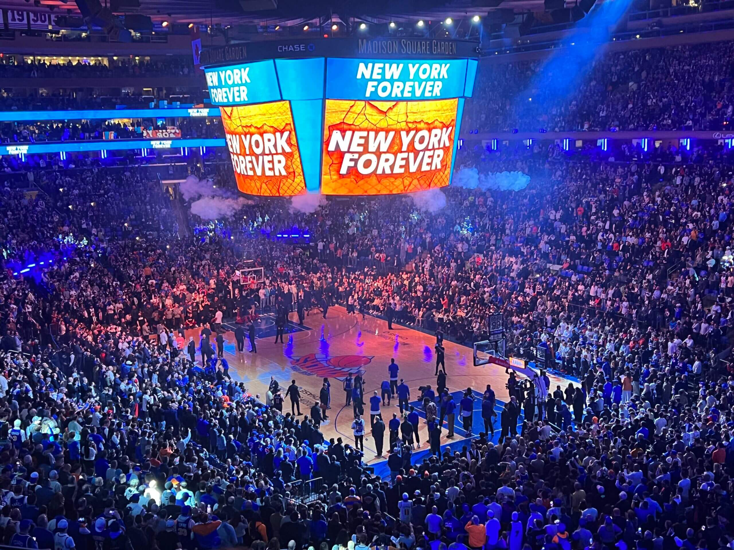

The home page will feature this image of the crowd at a Knicks playoff game, with a headline that says, “Where Icons are Born.” It will also feature a short paragraph that explains the purpose of the website and the content viewers will see. I will also have quick links to the other two pages, which are “IconKnick players” and “IconKnick moments.”

1. What will be on the 2nd page?  
   The 2nd page, “IconKnick players”, will highlight the greatest players in Knicks history, who will be grouped by decade. For example, the 1970s will feature Walt Frazier and Willis Reed, the ‘90s will highlight Patrick Ewing, and the 2020s will highlight Jalen Brunson. I will show the players’ statistics and accomplishments, and I will include a picture of each player, like the one of Brunson below.

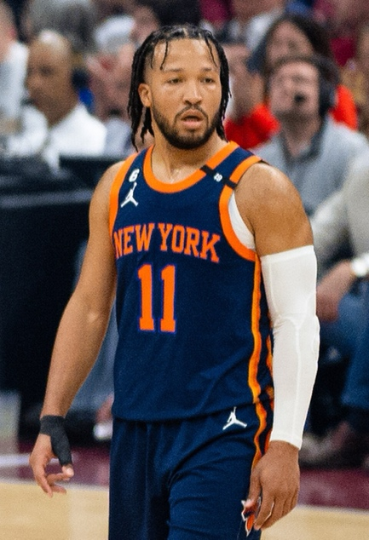

Lastly, the page will have links to the home page and page 3, “IconKnick moments.”

1. What will be on the 3rd page?

The 3rd page, “IconKnick moments,” will highlight the most memorable moments in Knick history, such as their two championships in the 1970s, their two finals appearances in the 1990s, and their first Eastern Conference Finals appearance in 25 years in 2025. The page will also include links to the first 2 pages. I will also include a picture of each moment, for example, the picture below, after the 1970 championship.

